Chapter 10 Extra Activity 2

Name _____________________________

Presidential Signature Activity

Directions: Study the examples of presidential handwriting. Then using the information you learned in Chapter 10, complete the tables and answer the questions that follow.

Document #1:
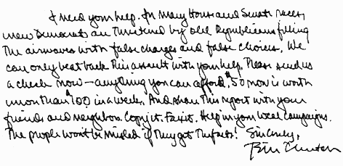

Four Signatures of U.S. Presidents with Dates of Service:
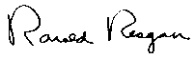
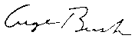
Ronald Reagan (1981-1989)
George Bush (1989-1993)
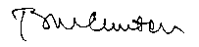
Bill Clinton (1993-2001)
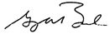
George W. Bush (2001-)

Document #2:
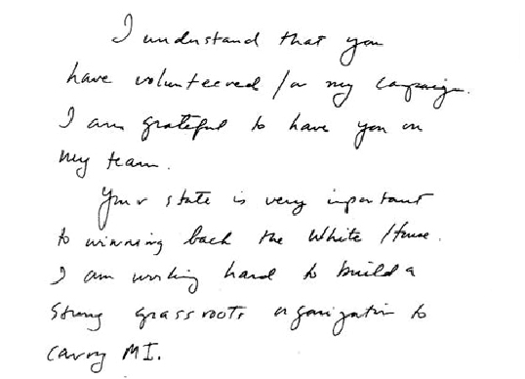

Data Table 1 Analysis Writing Sample 1

Exemplar # | Yes | No | Description (and measurements in mm)
1) Is line quality smooth?
2) Is spacing of words and margin evenly spaced? |  |  | Margins:
2) Is spacing of words and margin evenly spaced? |  |  | Words:
3) Is ratio of small letters to capital letters consistent?
4) Is the writing continuous?
5) Are letters connected between capitols and small case letters?
6) Are letter formations complete? |  |  | Be specific, which letters?
7) Is all the writing cursive? |  |  | (which words?)
8) Is the pen pressure the same?
9) Do all letters slant to the right?
10) Are all letters written on the line?
11) Are there fancy curls or loops? |  |  | (which letters?)
12) Are all i’s and t’s dotted and crossed?

Data Table 2 Analysis of President Ronald Reagan’s Signature

Exemplar # | Yes | No | Description (and measurements in mm)
1) Is line quality smooth?
2) Is spacing of words and margin evenly spaced? |  |  | Margins:
2) Is spacing of words and margin evenly spaced? |  |  | Words:
3) Is ratio of small letters to capital letters consistent?
4) Is the writing continuous?
5) Are letters connected between capitols and small case letters?
6) Are letter formations complete? |  |  | Be specific, which letters?
7) Is all the writing cursive? |  |  | (which words?)
8) Is the pen pressure the same?
9) Do all letters slant to the right?
10) Are all letters written on the line?
11) Are there fancy curls or loops? |  |  | (which letters?)
12) Are all i’s and t’s dotted and crossed?

Data Table 3 Analysis of President George Bush’s Handwriting Sample

Exemplar # | Yes | No | Description (and measurements in mm)
1) Is line quality smooth?
2) Is spacing of words and margin evenly spaced? |  |  | Margins:
2) Is spacing of words and margin evenly spaced? |  |  | Words:
3) Is ratio of small letters to capital letters consistent?
4) Is the writing continuous?
5) Are letters connected between capitols and small case letters?
6) Are letter formations complete? |  |  | Be specific, which letters?
7) Is all the writing cursive? |  |  | (which words?)
8) Is the pen pressure the same?
9) Do all letters slant to the right?
10) Are all letters written on the line?
11) Are there fancy curls or loops? |  |  | (which letters?)
12) Are all i’s and t’s dotted and crossed?

Data Table 4 Analysis of President Bill Clinton’s Handwriting

Exemplar # | Yes | No | Description (and measurements in mm)
1) Is line quality smooth?
2) Is spacing of words and margin evenly spaced? |  |  | Margins:
2) Is spacing of words and margin evenly spaced? |  |  | Words:
3) Is ratio of small letters to capital letters consistent?
4) Is the writing continuous?
5) Are letters connected between capitols and small case letters?
6) Are letter formations complete? |  |  | Be specific, which letters?
7) Is all the writing cursive? |  |  | (which words?)
8) Is the pen pressure the same?
9) Do all letters slant to the right?
10) Are all letters written on the line?
11) Are there fancy curls or loops? |  |  | (which letters?)
12) Are all i’s and t’s dotted and crossed?

Data Table 5 Analysis of President George W. Bush’s Handwriting

Exemplar # | Yes | No | Description (and measurements in mm)
1) Is line quality smooth?
2) Is spacing of words and margin evenly spaced? |  |  | Margins:
2) Is spacing of words and margin evenly spaced? |  |  | Words:
3) Is ratio of small letters to capital letters consistent?
4) Is the writing continuous?
5) Are letters connected between capitols and small case letters?
6) Are letter formations complete? |  |  | Be specific, which letters?
7) Is all the writing cursive? |  |  | (which words?)
8) Is the pen pressure the same?
9) Do all letters slant to the right?
10) Are all letters written on the line?
11) Are there fancy curls or loops? |  |  | (which letters?)
12) Are all i’s and t’s dotted and crossed?

Data Table 6 Analysis of Second Writing Passage

Exemplar # | Yes | No | Description (and measurements in mm)
1) Is line quality smooth?
2) Is spacing of words and margin evenly spaced? |  |  | Margins:
2) Is spacing of words and margin evenly spaced? |  |  | Words:
3) Is ratio of small letters to capital letters consistent?
4) Is the writing continuous?
5) Are letters connected between capitols and small case letters?
6) Are letter formations complete? |  |  | Be specific, which letters?
7) Is all the writing cursive? |  |  | (which words?)
8) Is the pen pressure the same?
9) Do all letters slant to the right?
10) Are all letters written on the line?
11) Are there fancy curls or loops? |  |  | (which letters?)
12) Are all i’s and t’s dotted and crossed?

Questions:

- Based upon your analysis, was it possible to identify the author of writing passage number 1.

- Justify your answer below using data obtained after your handwriting analysis.

- What difficulties did you have trying to match the writing passage # 1 with one of the four presidential signatures?

- Compare your answer with your other classmates. Do you agree or disagree on the author of this writing passage?
  - How many agree?

  - How many disagree?

  - Was anyone not sure of the author?

- How reliable is your handwriting analysis of the writing passage and the presidential signatures? Explain your answer.

- Based upon your analysis, was it possible to identify the author of writing passage number 2. Justify your answer below using data obtained after your handwriting analysis.

- What difficulties did you have trying to match the writing passage # 2 with one of the four presidential signatures?

- Compare your answer with your other classmates. Do you agree or disagree on the author of this writing passage?
  - How many agree?

  - How many disagree?

  - Was anyone not sure of the author?

- What other evidence would you request to be able to form a more reliable identification of the writing passages?

- List arguments below to explain why a single signature should not be used to identify the author of a writing passage.

